Brett Tomita

Relational Algebra Lab

1. RA: π Person

SQL: SELECT \* FROM Person;

Screenshot: 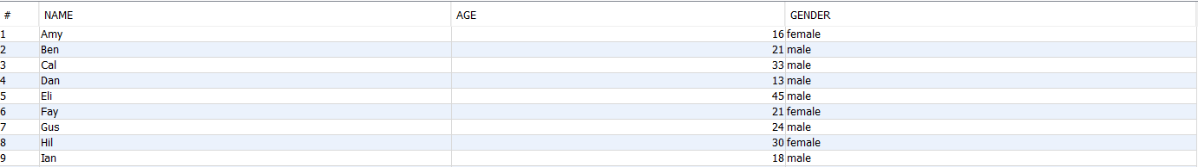

1. RA: π PizzaServes

SQL: SELECT Pizza FROM Serves;

Screenshot:

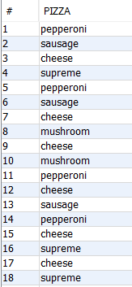

1. RA: π name, age σPizzeria = ‘Pizza Hut’ Person ⋈ Frequents

SQL: SELECT \* FROM Frequents natural join Person;

SELECT name, age FROM Person WHERE pizzeria = 'Pizza Hut';

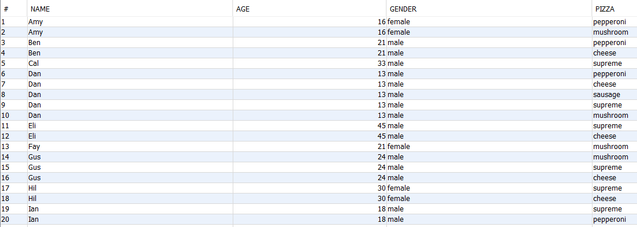

1. RA: π name, gender σeats = ‘Peperoni’ Person ⋈ Eats

SQL: SELECT \* FROM Person natural join Eats;

SELECT name, gender FROM Person WHERE pizzeria = 'pepperoni';



1. RA: π Pizzeria σprice < 9 .0 Frequents ⋈ Serves

SQL: SELECT pizzeria FROM serves WHERE price < 9.0;

Screenshot:

